Send your completed paper to Sandy Rutter at rutter@asabe.org by 13 April 2007 to be included in the ASABE Online Technical Library.
If you can't use this Word document and you'd like a PDF cover sheet please contact Sandy.
Please have Word's AutoFormat features turned OFF and do not include live hyperlinks. Your paper should be no longer than 12 pages. For general information on writing style, please see http://www.asabe.org/pubs/authguide.html.
This page is for online indexing purposes and should not be included in your printed version.

Author(s)
First Name | Middle Name | Surname | Role | Email
Zhen |  | LI |  | Mastr_lizhen@tom.com

Affiliation
Organization | Address | Country
College of Engineering, South China Agricultural University | WuShan, GuangZhou, GuangDong, 510642 | P.R. China

Author(s) – repeat Author and Affiliation boxes as needed--
First Name | Middle Name | Surname | Role | Email
Tian-sheng |  | HONG | ASABE Member ID: M0330870 | Tshong@scau.edu.cn

Affiliation
Organization | Address | Country
College of Engineering, South China Agricultural University | WuShan, GuangZhou, GuangDong, 510642 | P.R. China

Publication Information
Pub ID | Pub Date
073047 | 2007 ASABE Annual Meeting Paper



An ASABE Meeting Presentation

Paper Number: 073047

A Novel Method of Object Identification and Leaf Area Calculation in Multi-leaf Image
LI Zhen, Ph.D. Candidate
South China Agricultural University, GuangZhou 510642, P.R. China.
Phd_lizhen@scau.edu.cn
HONG Tian-sheng, Ph.D., Professor, Corresponding Author
South China Agricultural University, GuangZhou 510642, P.R. China.
tshong@scau.edu.cn
WU Wei-bin, Ph.D., Research Scientist
South China Agricultural University, GuangZhou 510642, P.R. China.
LIU Min-juan, M.Eng Candidate
South China Agricultural University, GuangZhou 510642, P.R. China.

Written for presentation at the

2007 ASABE Annual International Meeting

Sponsored by ASABE

Minneapolis Convention Center

Minneapolis, Minnesota

17 - 20 June 2007
Mention any other presentations of this paper here, or delete this line.
Abstract. Both advantages and disadvantages of CCD camera and flat scanner used as image taking equipment for leaf area measurement using digital image processing methods have been analyzed in this paper. For the main limitation of currently used leaf area measuring methods is that only one piece of leaf can be measured separately, a novel algorithm based on MATLAB and flat scanner has been figured out to measure leaf areas synchronously in a multi-leaf scanned digital image. Results of experiments were: the accuracy of leaf identification when no superposition between leaves was 100%, the relative error of calculated leaf area between using this method and in weighing method was 2.43%, the determination coefficient R² was 0.9996. Results indicated that this method can be used in the object identification and leaf area calculation in a multi-leaf scanned image.

Keywords. flat scanner, target identification, leaf area, image processing, region marking

Introduction
Leaf area is an important index when studying the plant physiology, bio-chemistry, heredity, breeding and crop cultivation techniques. The establishment of a convenient, fast, accurate and non-destructive leaf area measurement method plays an important role in adjusting the community structure and making good use of solar energy resources, which can guide the farm crop cultivation density and reasonable fertilizer to acquire higher production (Pang, 2004).
There have been many methods to measure the leaf area and each has its advantages and shortcomings (Yang, 2002; Wang, 2003; Bryan W, 1992; Bao, 2002). It is very difficult, however, to determine which method is the most suitable one. Among them, using the professional leaf area measuring instrument has obtained the highest accuracy so far. But these kinds of instruments are mostly imported in China, their expensive price makes them unsuitable for lots of Chinese research institutes and they failed to measure the leaves which were too long or too wide (Feng, 2005), or to measure more than one piece of leaf at the same time. Since a single piece of leaf couldn’t reflect the physical condition of the tree in which it is growing, leaf area measurement for one tree usually takes the leaves from the whole canopy and this number is usually up to several hundred. If we use the leaf area measuring instruments to calculate one piece of leaf in several minutes, then the whole measuring would be a time consuming procedure.
A fast way of leaf area measurement is using the digital image processing methods. Currently, a CCD camera or flat scanner serve as the chief obtaining equipments of digital image. Although the CCD camera can collect the plant’s picture and measure leaf area non-destructively, its result is affected seriously by the object distance, sampling angle, lighting condition and mutual superposition within the leaves so that the accuracy of leaf area measuring is low when using a CCD camera. The other method is using a flat scanner as a leaf image obtaining equipment. Though it is a destructive method because that leaves have to be picked off from a branch, the results are hardly influenced by artificial factors so that they are more precise and stable. There is insignificant impact on the results of measuring leaf shape, size, color, thickness when using this method and the equipments are easy to obtain, the measuring procedure is fast, the results are accurate, all these advantages lead to a wide applying scope of flat scanner as an image obtaining equipment(Li, 2006).
However, the computer programs developed for leaf area measurement using a flat scanner as an image taking equipment so far could measure one piece of leaf each time, just as that of the professional leaf area measuring systems. The goal of this study is to develop an algorithm to automatically identify different leaves within one multi-leaf picture and measure their areas synchronously.

Method and material

Leaf area calculating method
One digital image in computer is composed of pixels, and each pixel represents certain area in a real leaf. If we scan an object with a certain area (for example 1cm2) previously and find out how many pixels its scanned image contains as a reference, then we use a real leaf and calculate the pixels its scanned image possesses, by using the equation (1), we can deduce the real area that piece of leaf has. The equation (1) is as followed:
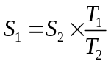 (1)
Where: S₁ is the real leaf area to be measured, S₂ is the area of reference object (in this paper S₂ is 1cm²), T₁ is total amount of pixels in leaf scanned image, T₂ is total amount of pixels in the image of reference object.
However, by using the method above, still only one piece of leaf could be measured separately. What have to be done are: (a) correctly find out how many leaves are scanned in the same image; (b) give each piece of leaf in the image a mark/label; (c) calculate the leaf areas sequentially of all the leaves within the image. All the three steps are carried out automatically using the algorithms introduced in this paper.

Equipments and software
The hardware equipments of this measurement mainly include one flat scanner and computer. The flat scanner used here is a ScanMaker 4850Ⅱ (Microtek, P.R. China), its main parameters are: 4800 × 2400 DPI CCD, 48-BIT Color, computer software tool kit ScanMaker 5.0. The main parameters of a scanned leaf image are: 300 DPI, 2481 × 3508 Pixels, 24-BIT gray image, saved in JPEG format. The computer system as a platform is: Intel Petium 4 3.60GHz, 1G DDR2 RAM. The programming software is the mathematical analysis software MATLAB 7.1 (Mathworks, USA).

Image processing procedure
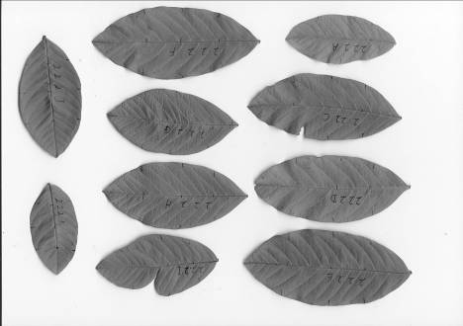

The image of reference objects as standard areas is shown in Figure1 (a), while the image of leaves waiting for area calculation is in Figure1 (b). Figure1 (a) is made using Photoshop (Version 7.0, Adobe Inc, USA) for precise areas. From the left to the right hand side, Figure1 (a) includes seven standard objects with certain area as: two blocks of 1 × 1 cm², one block of 2 ×2 cm², one block of 3 × 3 cm², one block of 4 × 4 cm², one block of 5 × 5 cm² and one block of 6 × 6 cm²; Figure1 (b) is a scanned image of 10 pieces of pomegranate leaves waiting to be calculated for leaf area, respectively. They have been regulated artificially to avoid mutual superposition.
a. Image of standard objects made from Photoshop
b. Image of scanned leaves waiting for area calculation
Figure 1. Image of standard objects and scanned leaves
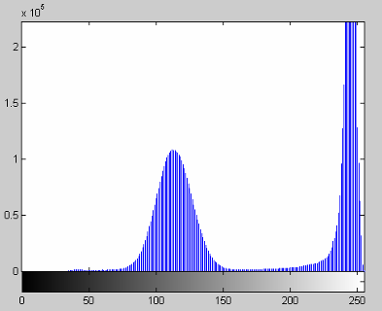
When the leaves are partitioned and their areas being calculated, the image to be used is in a binary format. But the images obtained from the scanner are in a 24-BIT gray format. Therefore we have to find a threshold by which the pixels within a gray image could be classified with a value “1” or “0” and the whole image is transformed into a binary format. When the pixel’s value in a gray image is above the threshold, it is reassigned a binary value “1”, while the pixel’s value is below the threshold, it is reassigned a binary value “0”. From Figure1 we can see that the image obtained from Photoshop or a scanner can be immune from the influence of outside factors, such as light, imaging angle, etc. There are obvious differences in gray values between the target area (the blocks or leaves) and the background, so we can use the histogram as a partition threshold method directly. The histogram of Figure1 (b) is shown in Figure2.
Figure 2. Gray value histogram of Figure 1(b)
Pixel Gray Value
Amount of Each Gray Value

Threshold decision
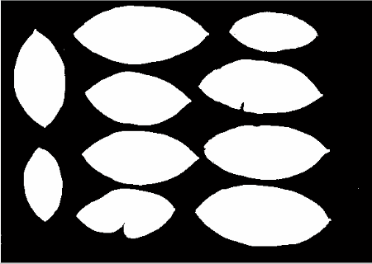
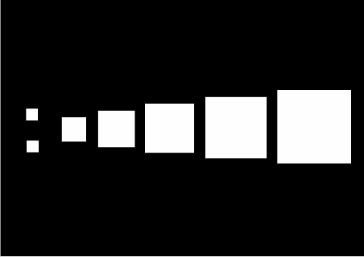
From Figure2 we can see that the histogram of scanned image has good double apices characteristic so that the partition could be carried out according to the threshold of the apex valley which is about 160 in this picture. In this experiment, there are in total 38 scanned images and the apex valley of each has been used to calculate an average value for the threshold. Finally, a value of 166 was fixed as the threshold. By using it, gray images in Figure1 are transformed to binary images as shown in Figure3.
Figure 3. Binary Image derived from Figure 1
a. Binary image derived from Figure 1(a)
b. Binary image derived from Figure 1(b)

Noise elimination
Although the obtained image using a scanner can overcome the external interference to a large extent, it still contains certain degree of noise which may not be seen by human eyes. These noises usually expresses in the way of some isolated pixels or small connected groups. If this kind of interference is not eliminated, the veracity of target identification and leaf area calculation will be influenced. It is discovered that there are much more differences in the amount of pixel between the noise and the target areas. The pixel amount of target area is usually in 10⁴～10⁵ amount level while the pixel amount of noise is usually in 10～10² amount level. As a result, the basic morphologic operation method could be adopted for noise elimination. The corrosive operation sign of erosion is Θ. Its definition is as in equation (2):
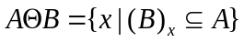 (2)
Where: A is the nonzero element in the original image (including target and noise), B is a kernel matrix adopted in the erosion operation, x is the nonzero elements within the image after erosion operation. In this experiment, B represents a 7 × 7 matrix with its whole elements as “1” in equation (3):
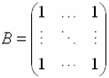 (3)
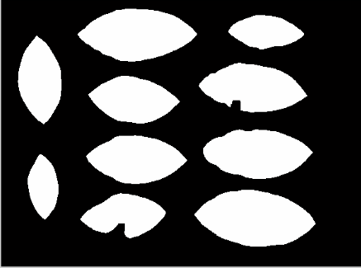
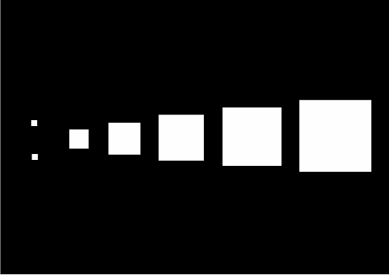
For removing all the noises, this experiment carries out a 10 times erosion operations, in other words it’s an over-erosion operation which will erode the areas in one image for 10 times to make sure that all the noises are eliminated. Figure4 is obtained after the erosion operations of Figure3. According to the repeated experiments, noise in the image can be completely removed after the erosion operations. Although the configuration and area of target changed within the erosion, most of the target areas could be reserved and these are regarded as the initial growth district in the area calculation.
Figure 4. Binary Image from Figure 3 after erosion
a. Binary image of standard objects after erosion operation
b. Binary image of scanned leaves after erosion operation

Area labeling
The area labeling is a crucial procedure of area identification of a binary image. The area labeling algorithm usually marks all the pixels within a target object (the pixel value of each is “1” and connect together) using an unique positive integer such as 1,2,3… It is also called labeling, coloring or connecting district marking (Sun, 2006). There are many ways to mark connecting areas, among which the 4-connecting area algorithm and the 8-connecting area algorithm are the most commonly used.
This experiment adopts the 4-connecting area algorithm. The labeling strategy is that a pointer scans an image row by row gradually, if a pixel with the value “1” is discovered, the pointer will search its 4-connecting areas shown in Figure5, then the pixels with value “1” inside the 4-connecting area will be labeled an integer the same as that in the center.
A new area starts when a pixel with value “1” rather than belonging to any of its adjacent areas comes out. This process would be carried on until all the pixels of that area are marked. After scanning all the pixels in an image, the area labeling is finished. Supposing the expression of area labeling is:
Figure 5. Searching strategy of labeling algorithm
1
[L, N] = label (I, n)
Where: I is the binary matrix that need to be labeled, n is 4 or 8, representing 4-connecting or 8-connecting area method. The result of the marking is returning a data matrix L whose size is the same as the imported image to be labeled and the district quantity N which tells us how many areas are in the image. Supposing the binary image matrix I is as equation (4), then matrix in equation (5) is the result of applying the 4-connecting area method. When the integer matrix L is obtained, we can use the different integers in L to distinguish the different object areas in the image.
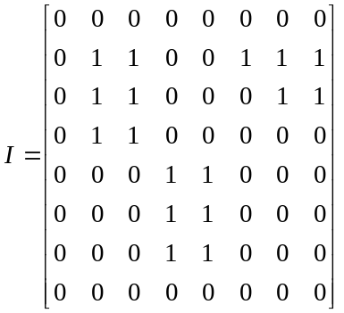 (4) 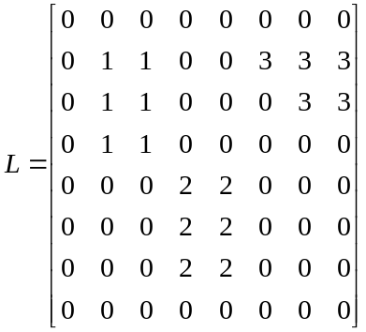 (5)
After marking Figure3 and Figure4, we can obtain 4 data matrixes L₁₁, L₂₁, L₁₂, L₂₂, and the connecting districts within each matrix are recorded respectively as: N₁₁, N₂₁, N₁₂, N₂₂, the connecting district quantity is: N₁₁=7, N₂₁=142, =7, N₂₂=10. The result that N₁₁ equals N₁₂ means that the images made by Photoshop have no noise, so the connecting area quantity before and after over-erosion is the same. While in the other hand, because of the existence of noises, the quantity of connecting area before over-erosion is much larger than that of the target areas in scanned image. After over-erosion, the number of the connecting area is the same as that of the target area in both of the image made by Photoshop or obtained from a scanner.

Object identification and leaf area calculation
Taking the binary images (Figure3 (b), Figure4 (b)) before and after the over-erosion operation as example, after labeling we obtained 2 data matrixes: L₂₁ and L₂₂, the number of connecting area inside each matrix is: N₂₁=142, N₂₂=10, respectively. It means that Figure3 (b) totally has 142 connecting areas and there are only 10 connecting areas in Figure4 (b). In the matrix L₂₂, after over-erosion, the remainder of target area is marked by integers 1～10, but in the matrix L₂₁, because of the existence of noises, the marking number of the target areas are unknown. The steps of identifying the target elements in the matrix L₂₁ according to L₂₂ and leaf area calculation are as followed:
(a) Pick out an element with the marking number “1” and is belonged to the connecting area No. “1” in matrix L₂₂, record its pixel position A(x, y) in matrix L₂₂ (Where x is the row position and y is the colum position). Because the original image of L₂₂ (Figure4 (b)) is derived from the original image of L₂₁ (Figure3 (b)) after over-erosion, it means that the connecting area No. “1” in L₂₂ must belongs to an area in L₂₁ which are in the same position. Therefore, in the matrix L₂₁ the pixel A(x, y)’s corresponding label k (1≤ k ≤ 142) is the marking number of the area No “1”. (b) By searching all the elements whose label number is k in L₂₁, we get the target area “1” in matrix L₂₁. (c) Record the element quantity of the target area No “1”, the number is equal to the pixel number T occupied by target area “1” in the original image. (d) Repeat the steps above until all the target areas and the reference objects’ areas have been identified and the corresponding quantity of pixel have been calculated. (e) Use equation (1) to calculate the leaf areas of each leaf.

Results and Discussion
Use the algorithm above to identify connecting areas in Figure3, calculate the pixel amount of each connecting area. In the calculation, A₁ and A₂ represent the area of reference objects square of which are 1cm², the rest areas are calculated according to equation (1).
For verifying the accuracy of this algorithm applied in leaf area measurement, we compared the calculation results with that using weighing method. Although all the methods used to measure leaf area so far are not very precise, the weighing method is more common and has higher accuracy as well as that the measuring theory is similar to the image method introduced above. By using the weighing method, we print the two images in Figure 1 using a laser printer (LaserJet 1200, HP, USA) within A4 papers. Tailor the objects (both the reference objects and the leaves in Figure1), obtain their weights using an electronic analyzing balance HF-300, the precision of which is 0.001g and calculate their areas using equation (6):
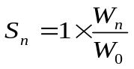 (6)
Where S_{n} is the area of a piece of leaf, W_{n} is the weight of that piece of leaf’s image printed in A4 paper and tailored out, W₀ is an average weight of the reference objects with an area of 1cm² tailored out from an A4 paper. The area measurement results of objects in Figure1 using this algorithm and that of weighing method are showed in table 1:

Table 1. Leaf area measuring results of current algorithm and the weighing method
Area No. | Pixel Amount | Area/cm2 | Area No. | Pixel Amount | Area/cm2 | Area Using Weighing Method/cm2 | bias
A1 | 13924 | 1 | B1 | 540842 | 38.8424 | 39.85 | -2.59%
A2 | 13924 | 1 | B2 | 295452 | 21.2189 | 22.02 | -3.77%
A3 | 55696 | 4 | B3 | 184189 | 13.2282 | 13.47 | -1.83%
A4 | 125316 | 9 | B4 | 397391 | 28.5400 | 29.14 | -2.10%
A5 | 222784 | 16 | B5 | 446152 | 32.0419 | 32.98 | -2.93%
A6 | 349281 | 25.0848 | B6 | 318706 | 22.8890 | 23.38 | -2.15%
A7 | 502681 | 36.1018 | B7 | 346422 | 24.8795 | 25.46 | -2.33%
 |  |  | B8 | 420202 | 30.1783 | 30.98 | -2.66%
 |  |  | B9 | 498885 | 35.8291 | 36.32 | -1.37%
 |  |  | B10 | 225724 | 16.2111 | 16.63 | -2.58%
In table 1, areas A_{n} represent the reference objects in Figure1 (a) while areas B_{n} represent the leaves in Figure1 (b). As using equation (1), T₂ is the average pixel amount of A₁ and A₂ which is 13924, T₁ is the pixel amount of each object and S₂ is 1cm², then the other areas are calculated from S₁.
From table 1 we can see that, the reference object areas A₆ and A₇ are not as precise as they are supposed to be in Figure3 (a), the relative error of them are: 0.34% and 0.28%, respectively. Generally the leaf areas calculated using image method introduced in this paper are smaller than that of using the weighing method, and the absolute average of relative error is 2.43%. Because there are a lot of reasons which will cause these errors, this research no longer does a detailed discussion about their presence here. Carrying out a regress analysis of leaf area from these two methods where the area calculated using weighing method serve as X coordinates and area from this algorithm serve as Y coordinates, they have prominent relation (R²=0.9996). As a result, the algorithm presented in this paper can be applied in the actual measurement of leaf area.
The reason why the real leaves are not used here for area calculation in the weighing method is that their weights, most of which are from the water content, changed significantly according to the period they are picked out from the branches. Each leaf (274 pieces in total) used in this experiment has been weighed twice. The first time was that as soon as being picked out from a branch, each leaf was measured using the balance HF-300 and got its wet weight marked as W_{t}. After being dried out in an oven for 48 hours, each leaf was measured for the second time for its dry weight marked as W_{d}. By using the regression (profile shown in Figure 6), the relationship between W_{t} and W_{d} is as in equation (7):
W_{t} = 2.4424×W_{d}+0.023 (7)
The R² of equation (7) is 0.9731. It means that the wet weight of a leaf is more than twice as its dry weight. If a real leaf was used for area calculation in weighing method, then its water content would influence the result significantly.
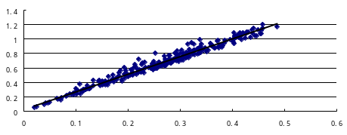
According to target identification carried out using the scanned images (total amount is 38), it is stated that the district identification accuracy is 100% in condition that no superposition happened; when superposition happens (as circled in Figure7), the algorithm will identify a connecting district mistakenly. So, when scanning leaves, it’s recommended that the leaves should be kept in a certain distance to avoid superposition.
Figure 6. Profile of relationship between W_{d} and W_{t}
Dry weight Wd/g
Wet weight Wt/g
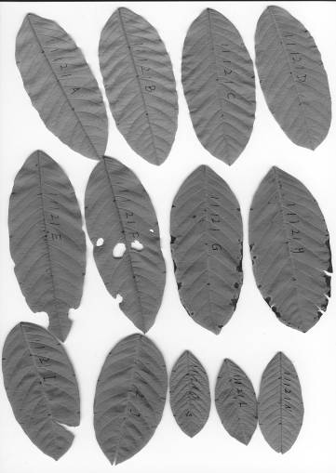
Conclusion
Figure 7. Scanned leaf image with superposition (as circled)
(1) Making use of this algorithm to develop a program based on MATLAB, we have carried out the identification of each independent leaf and the calculation of leaf area in multi-leaf scanned image. Leaf area from using this method is smaller than that using weighing method in general, and the absolute average error is 2.43%, the relative decision coefficient is 0.9996.
(2) Although the algorithm is designed for images from a scanner, its basic theories can be applied in the CCD camera imaging used for a non-destructive measurement of leaf area, but the threshold partition and the noise elimination methods should be re-designed according to the situation.
(3) The leaves in this experiment all came from one plant, the color of them is even and they have no obvious spot or breakage. In the later researches, different plant categories and leaves from different plants within a category are needed to improve the algorithm.

Acknowledgements
This work was funded by the GuangDong Science and Technology Project: “Research of Non-destructive Fruit Quality Measurement based on the Hyper-spectral Image Technology”, the serial number of it is: 2006B50106002. We are grateful to the Precision Agriculture Lab in South China Agricultural University for providing us the basic instruments needed in the experiments.
References
BAO Ya-jing, LI Zheng-hai, ZHANG Ying. 2002. Comparison of Measure Methods of Leymus chinensis Leaf Area. Acta Scientiarum Naturalium Universitatis Neimongol, 33 (1): 62-64
BEI Jun-hua, WANG Ke-ru, CHU Zhen-dong, CHEN Bing, LI Shao-kun. 2005. Comparitive Study on the Measure Methods of the Leaf Area. Journal of Shihezi University(Natural Science), 23 (2): 216-218
Bryan W, Ben Mullinix. 1992. Comparing six methods of various complexity for calculating leaf area from measurement of leaf width and length. Toc Sci (36) :40-42
Feng Dong-xia. 2005. Research of portable leaf area measuring instrument. Thesis for M.Eng, China Agricultural University
KEBOE A, PARKER G A. 1990. Image processing for industrial radiograph inspection: image enhancement. British Journal of NDT, 32(4): 183-190
PANG Hong-xi, PEI A-wei, HE Bei-ru, WANG Yi. 2004. Study on canopy temperature and its biological characteristics of high spike weight wheat. Journal of Northwest Sci-Tech University of Agriculture and Forestry, 32(12): 23-27
LI Bao-guang, TAO Xiu-hua, NI Guo-ping, HUANG Dong-hua, SONG Xiao-min. 2006. Study on Determining Plant Leaf Area by Scanning Image Pixels Method. Acta Agriculturae Jiangxi, 18 (3): 78-81
Liu Guanjun, Wang Dahai, Guo Xiaorui, Yang Chuanping, Jiang Jing, Feng Xin. 2004. A Rapid and Accurate Method for Determining Leaf Area. Journal of Northeast Forestry University, 32 (5): 82-83
Matthew E O’NEAL, Douglas A. 2002. LANDIS, Rufus ISSACS. An Expensive, Accurate Method for Measuring Leaf Area and Defoliation Through Digital Image Analysis. Field and forage crops, 95(6): 1190-1194
SUN Jian-cheng, ZENG Pei-feng, YU Su-ping, WU Xiong-ying. 2006. Component labeling and noise eliminating of binary image. Journal of Tianjin Polytechnic University, 25 (1): 45-47
Van Henten E J. 1995. Non-destructive crop measurement by image processing for crop growth control. J of Agriculture Engineering Research, (61): 97-105
WANG Jiabao, LIN Qiujin, YE Shuide, LU Yeling. 2003. Studies on Five Methods for Measuring Leaf Area of Some Tropical Fruit Trees. Tropical Agriculture Science, 23 (1): 11-14
Wu Congling, Teng Guanghui, Li Changying. 2005. Application and validation of computer vision based nondestructive measurement system for cucumber seedling growth conditions. Transactions of the CSAE, 21 (4): 109-112
Yang Jinfeng, Chen Qing, Han Xiaori, Li Xiaolin, H.P.Liebig. 2002. Measurement of Vegetable Leaf Area Using Digital Image Processing Techniques. Transactions of the CSAE, 18 (4): 155-159

